# Data Origin

The project is inspired from [Data Analyst Portfolio Project #1 | Build a Database | Develop SQL | Create a Dashboard](https://www.youtube.com/watch?v=S2zBHmkRbhY)

However, there were plenty of mistakes in the project initiation and its solution. Therefore, I decided to re-create this project with true findings. The original data can be found from [here](https://www.absentdata.com/hotel_revenue_historical_full/) which has been used for this project.

# Hotel data analysis Project: Building data story/dashboard using Power BI to present our stakeholders.

**Pipeline:**

1. Building database
2. Developing the SQL Query (via Microsoft SQL Management Studio 18)
3. Connecting Power BI to SQL Database via query
4. Visualizing the business questions in Power BI
5. Forecasting via Tableau
6. Summarizing findings

# Business Questions:

1. **Is our hotel revenue growing by year?**

There is a huge increase from 2018 to 2019, yet there is a decrease from 2019 to 2020 overall.

While City hotel is growing, Resort Hotel is failing to grow.

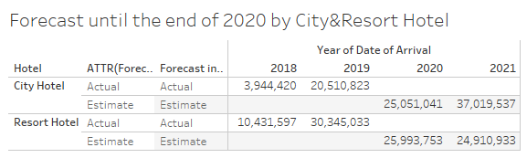

Please refer from here for the full forecast: https://public.tableau.com/app/profile/alper5134/viz/Forecast_16373695849180/Sheet2?publish=yes

1. **Should we increase our parking lot size?**

There is a no need to increase the parking size for City Hotel, however we may consider increasing parking lot size for Resort hotel. However, we should check each hotel location and decide based on that.

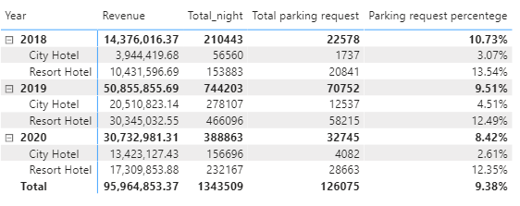

1. **What trends can we see in the data?**

Based on the previous question, please see the parking slot request by assigned room type in following. It might give us some further insights. 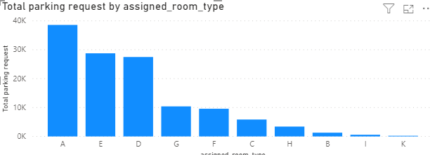

Additionally:

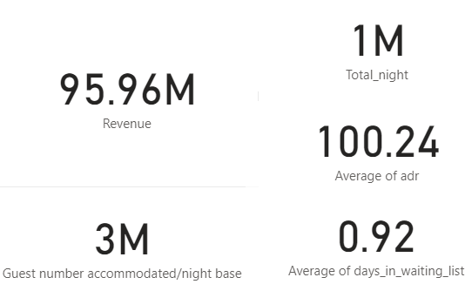 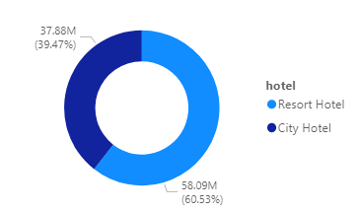

Please refer to Power BI Visualizations for further.